**DEPARTMENT OF INFORMATION TECHNOLOGY**

**Course Name and Code:** Data Structures Lab **(**ITL302)

**Semester:** III (SYIT)

**Academic Year:** 2024-25 (Odd Semester)

**Experiment No. 01**

**Aim:**  Implementation of Stack using an array for real-world application.

**Code:**

#include <stdio.h>

#define MAX 100

typedef struct {

int arr[MAX];

int top;

} Stack;

void push(Stack *s, int value);

int pop(Stack *s);

int peek(Stack *s);

void display(Stack *s);

int main() {

Stack s;

s.top = -1;

int choice, value;

do {

printf("\nStack Operations Menu:\n");

printf("1. Push\n");

printf("2. Pop\n");

printf("3. Peek\n");

printf("4. Display\n");

printf("5. Exit\n");

printf("Enter your choice: ");

scanf("%d", &choice);

switch (choice) {

case 1:

printf("Enter value to push: ");

scanf("%d", &value);

push(&s, value);

break;

case 2:

value = pop(&s);

if (value != -1)

printf("Popped value: %d\n", value);

break;

case 3:

value = peek(&s);

if (value != -1)

printf("Top value: %d\n", value);

break;

case 4:

display(&s);

break;

case 5:

printf("Exiting...\n");

break;

default:

printf("Invalid choice! Please enter a number between 1 and 5.\n");

break;

}

} while (choice != 5);

return 0;

}

void push(Stack *s, int value) {

if (s->top == MAX - 1) {

printf("Stack overflow!\n");

} else {

s->arr[++s->top] = value;

printf("Pushed %d onto the stack.\n", value);

}

}

int pop(Stack *s) {

if (s->top == -1) {

printf("Stack underflow!\n");

return -1;

} else {

return s->arr[s->top--];

}

}

int peek(Stack *s) {

if (s->top == -1) {

printf("Stack is empty!\n");

return -1;

} else {

return s->arr[s->top];

}

}

void display(Stack *s) {

if (s->top == -1) {

printf("Stack is empty!\n");

} else {

printf("Stack elements are:\n");

for (int i = s->top; i >= 0; i--) {

printf("%d\n", s->arr[i]);

}

}

}

**Output:**

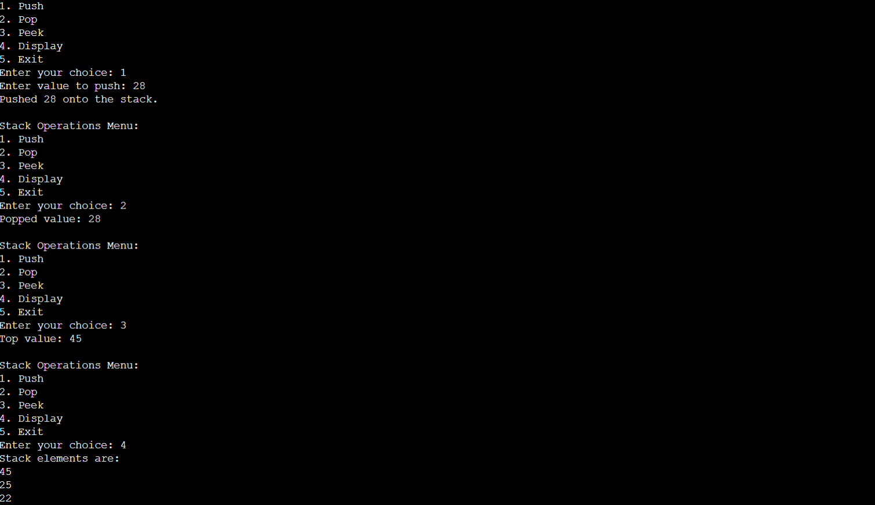

**Submitter Details:-**

**Name:** Abhinav S Dasari

**Roll No:** 16

**Div -** A

**Batch -** S-2